The Prequel  
GDD

**Overview**

**Product Details**

* Players
  + Single Player
* Genre
  + Casual, Isometric, Endless Driver
* Platform
  + PC/Switch
* Outlets
  + Steam, Nintendo Store, Epic

**Summary**

Jen is unhappy at work and decides one day to just leave in the middle of it and take to the road, she has no aim, no direction, wherever the road takes here, that is where she will be.

She has a radio on her car that was a gift from her grandfather, she tunes in to hear music and at times odd random radio transmissions.

Jen must be also mindful of how much fuel and food she has and if she has rested, so from time to time she will have to stop at a gas station and or an inn to rest.

**Pillars**

* Random Road Encounters
  + As Jen is on the, she can choose when she can stop her car and deal with whatever the encounter may be.
    - Encounters can be from stopping at a gas station, picking up a hitchhiker, stopping to look at a view.
* Radio
  + Jen can tune into the radio anytime.
    - Radio transmissions will be random from music to regular fictionalised broadcasts
* Narrative Driven
  + Jen will have dialogue choice with the characters she encounters

**Game Loops**

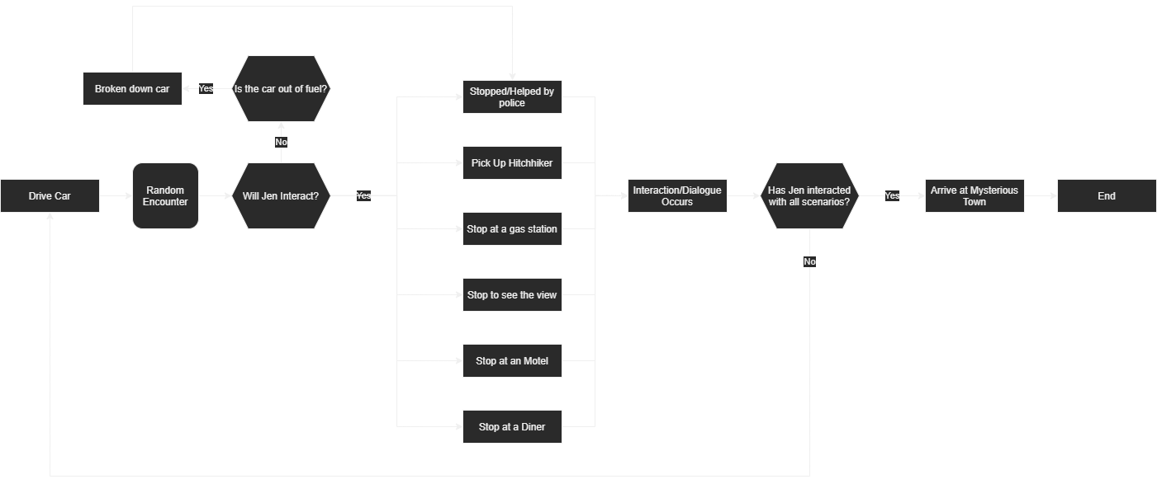

**Mechanics**

* Movement & Camera
  + It is a fixed Orthographic camera, and movement is just a button held down to drive the car
  + When Jen is walking, it will change to point and click and the camera will follow in an orbit fashion, similar to the sims
* Dialogue
  + Jen can interact and choose the dialogue response when speaking to other NPC’s
* Menu
  + Simple menu system with play, continue, volume controls and exit
* Interaction
  + Jen can interact with objects such as food, answer a phone, play the radio
* Radio
  + The radio is a gift to Jen from her grandfather
    - The radio is old timey looking and can be tuned to radio stations to play music or fictionalised broadcasts

**Systems**

* Day and Night Cycle
  + To have a sense of the passage of time, there is a day and night cycle
* Broadcasts
  + While the broadcasts are random, there is a sub story that hints to Jen that she has entered a twilight zone moment, strange things are being said. (this needs to be clarified better)